**DAILY ONLINE ACTIVITIES SUMMARY**

|  |  |  |  |  |  |  |  |  |
| --- | --- | --- | --- | --- | --- | --- | --- | --- |
| **Date:** | **16-06-2020** | | | | | **Name:** | **Anix Jugal D’Cunha** | |
| **Sem & Sec** | **8 sem , A sec** | | | | | **USN:** | **4AL16CS013** | |
| **Online Test Summary** | | | | | | | | |
| **Subject** | | **BDA** | | | | | | |
| **Max. Marks** | | **30** | | **Score** | | | **18** | |
| **Certification Course Summary** | | | | | | | | |
| **Course** | **Java basics, Java in Use //Complete course for beginners** | | | | | | | |
| **Certificate Provider** | | | **Udemy** | | **Duration** | | | **3.5 hours** |
| **Coding Challenges** | | | | | | | | |
| **Problem Statement:** Java Program to Convert Map (HashMap) to List | | | | | | | | |
| **Status: Competed** | | | | | | | | |
| **Uploaded the report in Github** | | | | | **yes** | | | |
| **If yes Repository name** | | | | | **alvas-education-foundation/dcunhaanixjugal** | | | |
| **Uploaded the report in slack** | | | | | **yes** | | | |

Online Test Details: (Attach the snapshot and briefly write the report for the same)

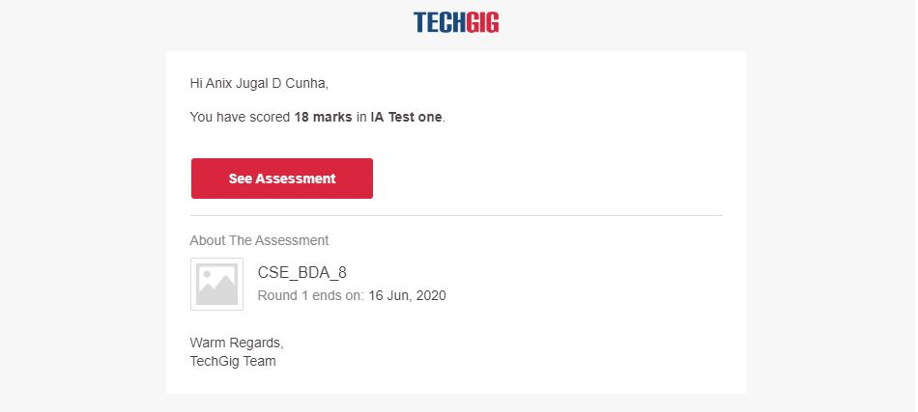

Certification Course Details: (Attach the snapshot and briefly write the report for the same)

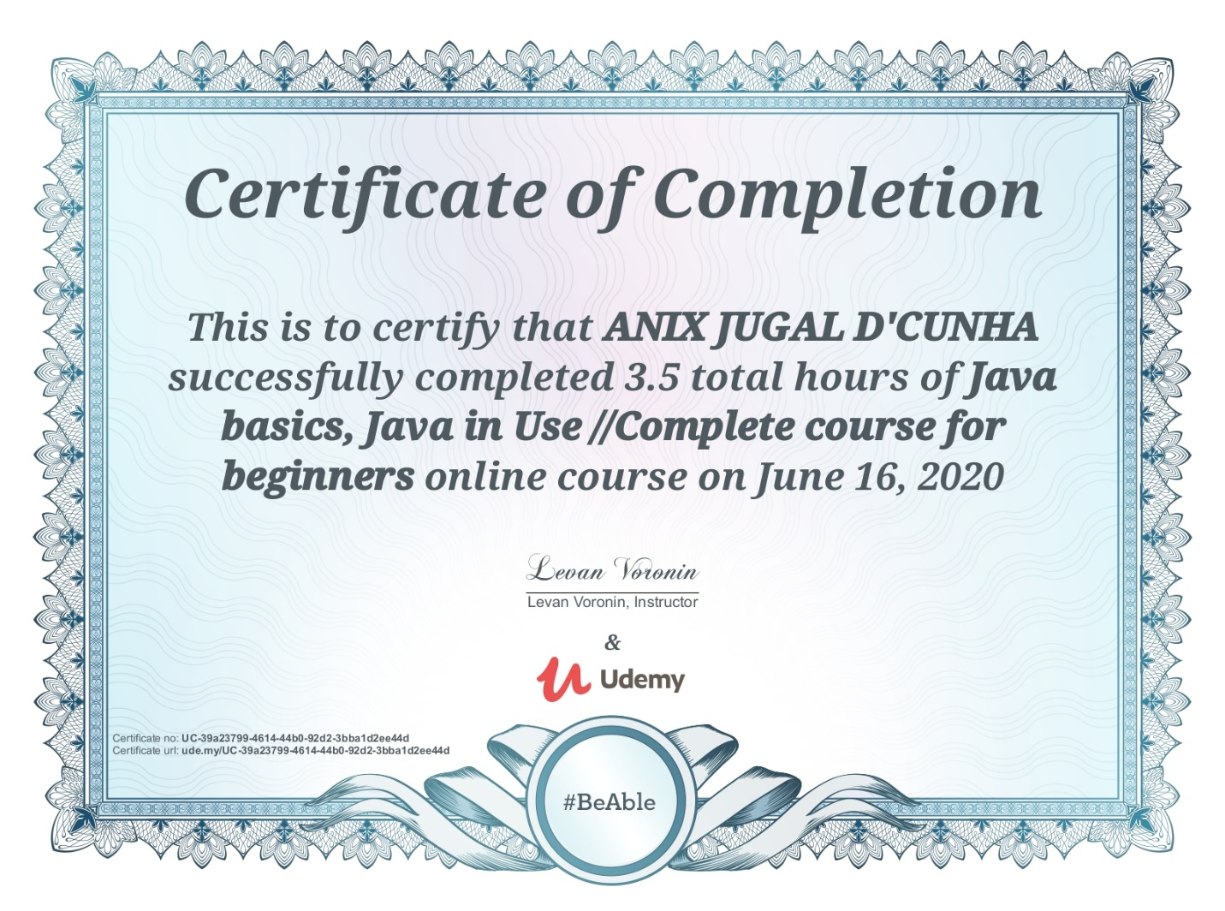

Coding Challenges Details: (Attach the snapshot and briefly write the report for the same)

Program-> Java Program to Convert Map (HashMap) to List

|  |  |
| --- | --- |
|  | |
|  | |  | |
|  | |  | |
|  | | import java.util.*; | |
|  | |  | |
|  | | public class MapList { | |
|  | |  | |
|  | | public static void main(String[] args) { | |
|  | |  | |
|  | | Map<Integer, String> map = new HashMap<>(); | |
|  | | map.put(1, "a"); | |
|  | | map.put(2, "b"); | |
|  | | map.put(3, "c"); | |
|  | | map.put(4, "d"); | |
|  | | map.put(5, "e"); | |
|  | |  | |
|  | | List<Integer> keyList = new ArrayList(map.keySet()); | |
|  | | List<String> valueList = new ArrayList(map.values()); | |
|  | |  | |
|  | | System.out.println("Key List: " + keyList); | |
|  | | System.out.println("Value List: " + valueList); | |
|  | |  | |
|  | | } | |
|  | | } | |
|  | |  | |
|  | |  | |